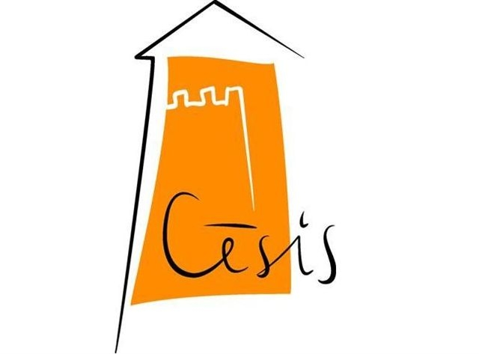
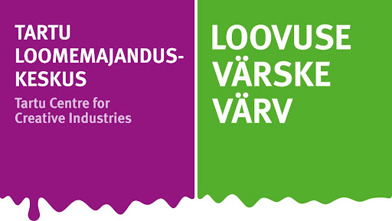

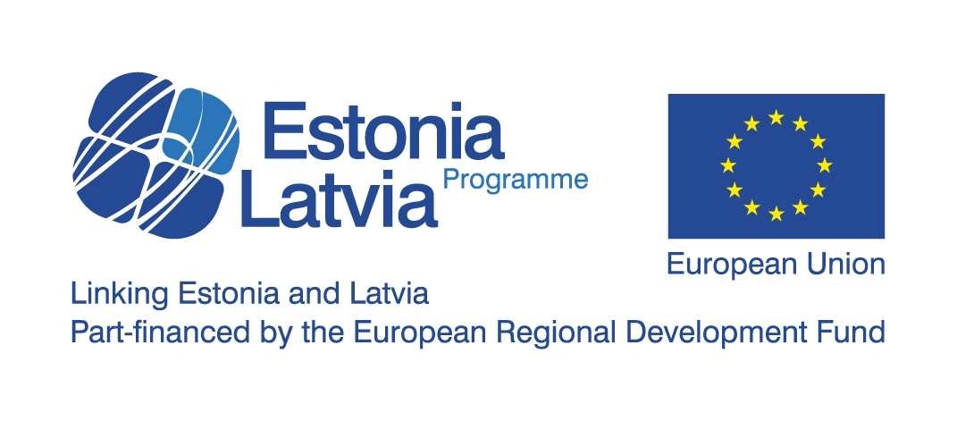




Conference
The role of artists and creative industries in local development
1st March 2013, Cēsis New Castle, 9 Pils Square, Cēsis, Latvia

The conference is organized as the final event in Latvian-Estonian cultural cooperation project “Local Artists for Regional Development”. The project aimed to connect artists with communities and to form a common network to boost the creative economy and social life in both partner cities – Cēsis (Latvia) and Tartu (Estonia).
The project used an innovative cross-border approach, based on the creative potential of artists living in regions. The challenge was to find new solutions for economic, social and environmental development of two cities, engaging local people in artistic activities to boost overall creativity. Reliable contacts between active cultural groups in both cities through numerous grass-root cultural exchanges were established. Thanks to the broad support and interest Culture Prize of Union of Baltic cities in 2012 was awarded to Cēsis and Tartu.
In the conference the results of the project will be presented, followed by the discussion on political agendas of creative industries in regions of Estonia and Latvia. Good examples of artists’ support schemes in regions of other EU countries will be presented and discussed.
Conference participants: Latvian and Estonian artists, creative industries' workers and regional development planners.
Organizer: Cēsis Culture and Tourism center in cooperation with Tartu Center of Creative Industries.
Conference program

10:30 Registration and coffee
11:00 Welcome by Cēsis vice-mayor Janis Rozenbergs
11:10 Presentation of Estonian-Latvian project “Artists for development” results
- Ilona Asare, Cesis Culture and Tourism center (LV)
- Kylli Hansen and Berk Vaher Tartu Center for Creative Industries (EE)
- Ilze Vitola, Arts education center “3 colours” (LV)

11:50 Creative Latvia and Creative Estonia – national policies for creative industries’ development in regions of Estonia and Latvia
- Eva Leemet, CEO of Creative Estonia
- Dzintra Purvina, Cultural Policy department of the Ministry of Culture of Latvia

12:30 Panel discussion “Policies for cultural industries in regions – unexplored possibilities”.
Moderator: Dace Melbarde (director of Latvian National Centre for Culture).

13:00 Lunch
14:00 Regional artists’ support schemes in European countries – presentations of case studies
- Lisbeth Rysgaard, ARTLAB (Denmark)
- Diana Pasek-Atkinson, Arts Development UK platform (UK)
- Elina Hermansone, “Brigādes” (Latvian centre for Contemporary Art)
Moderator: Dace Melbarde.

15:20 Panel discussion “Artists’ support schemes in regions”

16:00 Conclusions.

16:30 Latvian-Estonian performance and informal evening in Cēsis Exhibition hall.

Conference is organized with the support of Estonia-Latvia programme financed by European Regional Development Fund.

