Survey of Management of Energy Planning Procedures in Vidzeme Planning Region
Report within the framework of Work Package 3 of the Project
„Wood Energy and Cleantech”
Author: SIA „Ekodoma”
2011

Table of contents
Introduction 3
1. Analyses of energy policy planning documents 3
1.1. Analyses of policy documents of Vidzeme Planning Region 3
1.1.1. Long-term documents 3
1.1.2. Medium-term documents 5
1.1.3. Planning processes in the Vidzeme region 6
1.2. Energy planning documents of VPR in the context of the national policy 8
1.2.1. National energy policy 8
1.2.2. Strategies and planning documents in the energy sector 10
1.2.3. Analyses of the current VPR energy policy in comparison with the national objectives 11
1.3. Municipal planning documents in the context of VRP and national policy 11
1.3.1. Survey of the documents of the largest municipalities 11
1.3.2. Comparison and analyses of the development objectives of the municipal and VPR policies 13
2. Analyses of policy planning documents in the forestry sector 13
2.1. Analyses of the existing planning documents of VPR 13
2.2. VPR forestry planning documents in the context of the national policy 14
2.2.1. The national forestry policy 14
2.2.2. VRP forestry policy and the national development objectives 14
2.3. The municipal planning documents in the context with the VRP and the national policy in the forestry sector 14
3. Impact of energy policy on the environment 15
3.1. Climate policy 15
3.2. Availability of energy resources 16
4. Driving forces and hindrances in the elaboration of the energy policy 17
List of literature 19

Introduction
The report has been elaborated within the framework of Work Package 2 of the project „Wood Energy and Cleantech”. The objective of the report is to present an analytical survey of the management of planning procedures and the existing planning documents, as well as to evaluate if these procedures and documents are sustainable in the field of energy and forestry in the Vidzeme Planning Region and to compare them with the Latvian national policy and the directions of development. The target group of the report is local decision makers, the administration of the Vidzeme Planning Region and other institutions concerned.
The report was elaborated by Marika Rošā, Līga Ozoliņa and Dagnija Blumberga from SIA „Ekodoma”.

Analyses of energy policy planning documents

Analyses of policy documents of Vidzeme Planning Region
Two main development planning documents of the Vidzeme Planning Region (VPR) were elaborated in 2007:
- Development Programme of Vidzeme Planning Region 2007 - 2013;
- Territorial Plan of Vidzeme Planning Region 2007 – 2027.
Besides the above-mentioned planning documents, in 2010 VPR in co-operation with stakeholders elaborated the economic profile of the Vidzeme Planning Region as a review of the long-term economic development. The objective of the document is to highlight priorities in line with the regional economic features and development perspectives that would disclose the bases of the regional economic development, the driving forces of the regional development, as well as the preconditions necessary for the regional economic development.
The following sub-chapters present and analyse the energy development alternatives that are defined in the above-mentioned documents and compare them with the national energy policy.

Long-term documents
One of the basic elements of the vision stated in the Territorial Plan of the Vidzeme Planning Region 2007 – 2027 is to develop Vidzeme as a green region with beautiful landscapes, a unique nature territory, a rich cultural heritage and traditions.
The document has defined one long-term objective: to ensure the availability of energy resources and the sufficiency of capacity for the economic development of populated areas in the region.
The document has defined two medium-term objectives:
- To ensure availability of natural gas in the national and regional centres;
- To ensure a qualitative supply of the electrical energy to customers and to improve the distribution, supply and efficiency of energy.
The first objective will be achieved with the help of the following activities:
- When planning of the routes of gas pipelines, it shall be ensured that this resource is available to a maximum number of inhabitants; it would affect the development of the construction of individual houses and the establishment of new enterprises;
- Planning of the construction of gas pipelines in the regional centres where it is not available at the moment – in Smiltene, Alūksne, Gulbene, Madona, as well as in Valka where the supply could be possible from Valga (Estonia);
- Planning of the availability of the natural gas in the municipal centres, such as Ape, Rauna, Rūjiena;
- A number of settlements are situated close to the existing and possible gas pipelines and it is advisable to use the natural gas there: Naukšēni, Gaujiena, Vaidava, Jeri, Zilaiskalns.
The second objective will be achieved with the help of the following activities:
- To plan a new high voltage (330kV) line between the energy systems of Estonia and Latvia;
- To support research on the use of the alternative energy resources (geothermal, solar, etc.);
- To increase the number of the producers of the renewable energy resources and the rate in the total consumption;
- To develop the use of regenerative energy resources in the national economy;
- To develop the production of the biofuel.
The desirable development of the energy supply is depicted in Picture 1.
The two medium-term objectives are contradictory. The first objective is directed towards a complete gasification of the Vidzeme region that would mean the eradication of the local energy resources in the future. At present, in the areas where the natural gas is not available they use mostly wood. The activities to reach the second objective envisage a wider use of the renewable energy resources.
The economic profile of the VPR elaborated in 2010 presents the use of the local resources in the production of the thermal energy as one of the perspectives that will also provide additional jobs to local people, will reduce the dependency of the energy production from the imported resources and their prices on the world market.
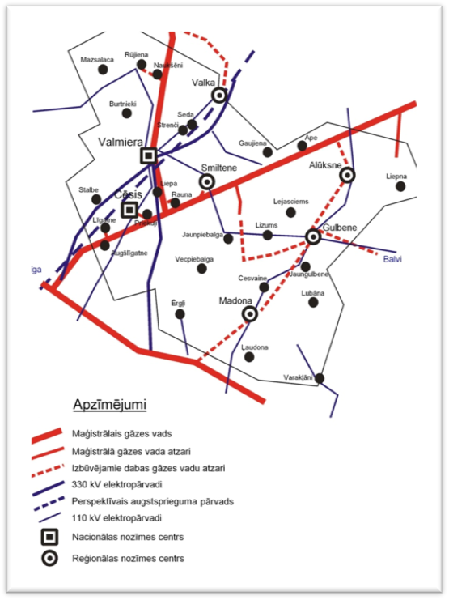
Picture 1. Development vision of energy supply in the VPR Territorial Plan 2007 - 2027.

Medium-term documents
The VPR Development Programme is a medium-term planning document for the period of 2007 – 2013; it presents the development variants of the VPR , the energy sector including. VRP defined four strategic priorities:
- Development of infrastructure and services.
- Economic development, increase of competitiveness and progress towards the knowledge-based economics.
- Development of human resources and promotion of employment.
- Rural development.
There are two medium-term objectives in the field of energy infrastructure:
- Natural resources are used efficiently applying environmentally friendly and modern technologies.
The following tasks will help to achieve the objective:
- To support the research on the availability of the natural gas in larger populated areas and industrial territories.
- To promote the use of gas in the economic sector.
- To promote the introduction and use of the alternative energy resources in the economic sector.
- To promote the introduction and use of the renewable energy resources in the economic sector.
- To promote the introduction of the environmentally friendly and energy saving technologies.
- To improve the infrastructure of heat supply.
- Improved energy efficiency of public and dwelling houses and heat supply facilities, decreased heat losses.
The following tasks will help to achieve the objective:
- To perform the energy audit of public and dwelling houses.
- To reconstruct public and dwelling houses and to increase their energy efficiency.
- To reconstruct the existing heat energy facilities and to construct the new ones.
- To promote the establishment and the introduction of the measures of the evaluation system of the energy efficiency and the technical quality of buildings.

Planning processes in the Vidzeme region
The processes of the territorial and development planning in Latvia are determined by the Law on regional development and the Law on the development planning system. The VPR Development Programme was elaborated in 2007, but the latest amendments in the Law on regional development were made in 2010 and several new provisions were added. The Law on the development planning system states one of the main provisions for the elaboration of development planning documents: they have to be in line with the long-term conceptual document “National Growth Model: People First”. The four levels of the territorial development planning documents in Latvia are depicted in Picture 2.
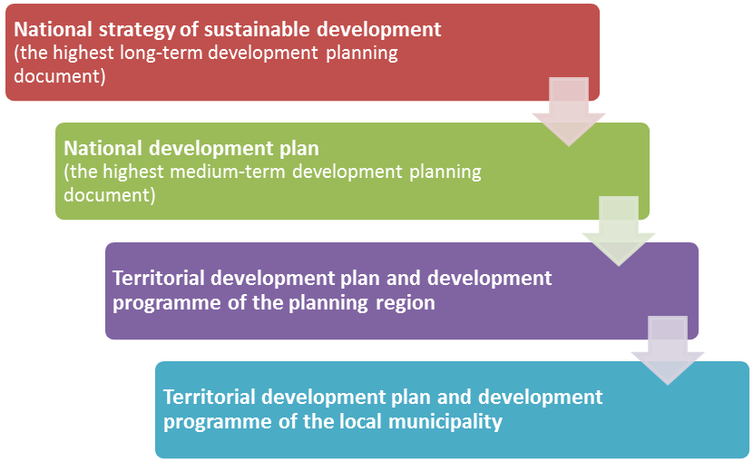

Picture 2. Territorial planning documents in Latvia
The development documents of the planning region as stated by the Law on regional development are listed in Picture 3.
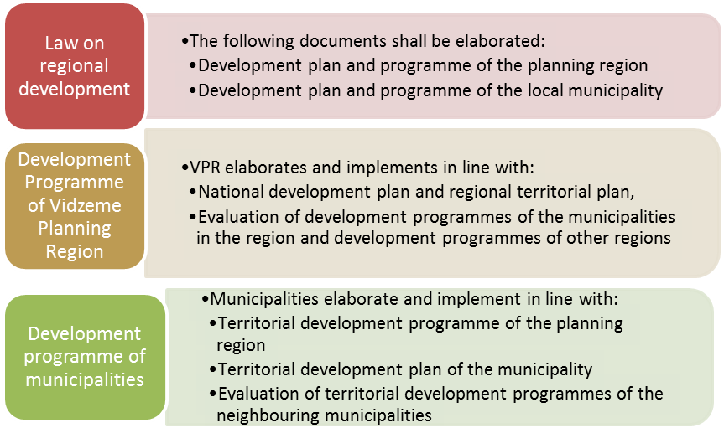
Picture 3. The development documents of the planning region as stated by the Law on regional development
The VPR Development Programme shall be elaborated by experts, but accepted by the Development Council. The main institutions of the Vidzeme Planning Region and their contiguity are presented in Picture 4.
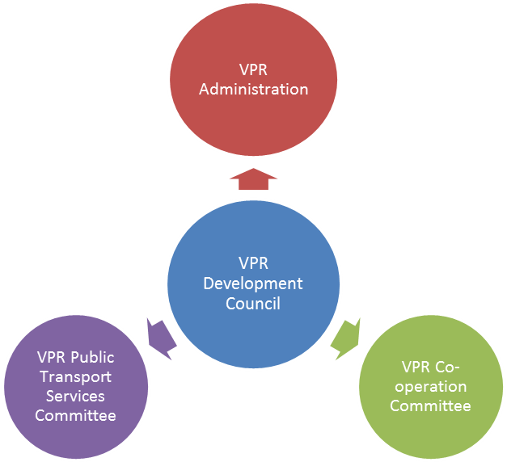
Picture 4. Institutions of the Vidzeme Planning Region
Picture 5 presents the main four steps of the procedure of planning, elaboration, approval and implementation of the VPR Development Programme. As it was already mentioned, the amendments of the Law on regional development concerning the new procedures of the elaboration and implementation of the regional development were made in 2010 and they became effective on January 1, 2011.
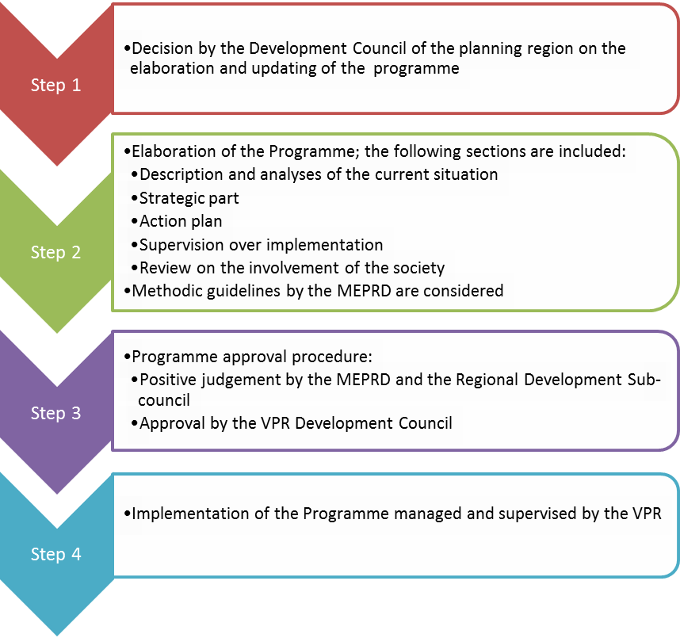Picture 5. Planning and implementation of the Development Programme of the Vidzeme Planning Region

Energy planning documents of VPR in the context of the national policy

National energy policy
The basic principles of the national energy policy are defined in the National Energy Development Guidelines 2007 – 2016 and the Guidelines of Renewable Energy Resources Usage 2006 - 2013. Both the documents were elaborated and approved in 2006 when the leaders of the European Union had not yet stated the three basic objectives to use renewable energy resources and to increase the energy efficiency that should be reached by 2020:
- Reduction of the primary energy consumption by 20% (as compared to the planned development tendency);
- Increase of the rate of the renewable energy resources (RER) by 20% in the total energy consumption;
- Reduction of the greenhouse effect gas emission by par 20% in comparison with the level of 1990.
Since 2006 the European Parliament has adopted several regulations that are binding to Latvia. The most important are the following:
- European Parliament and Council Regulation No. 2006/32/EK on the efficiency of final energy consumption and energy efficiency services laying down that Latvia has to achieve the energy saving objective of 9% in 2016 in comparison with the reference consumption in 2000 - 2004;
- European Parliament and Council Regulation No. 2009/28/EK on the promotion to use renewable energy resources (RER) – the objective of Latvia is to ensure the production rate of 40% of the renewable energy resources of the total final energy consumption;
- European Parliament and Council Regulation No. 2010/31/EK (19 May, 2010) on the energy efficiency of buildings laying down provisions for justifying the energy efficiency calculation method, minimum energy efficiency requirements for new and outsized buildings, as well as provisions for the energy certification of buildings and the testing and evaluation of the technical equipment.
During the last three years, a number of researches have been elaborated with an aim to evaluate the possibilities of Latvia to reach the objectives in the field of the renewable energy resources and the energy efficiency. One of them was elaborated by the Environmental Protection and Heat Systems Institute of the Riga Technical University - „Evaluation of possibilities to use renewable energy resources in Latvia by 2020”; the research showed that the current RER policy of the government would not ensure the achievement of the objective of the RER Regulations by 2020. Similar conclusions are presented in another research elaborated by other energy experts - „Use of renewable energy resources to ensure the sustainable development of Latvia”.
The document „Sustainable development strategy of Latvia by 2030” envisages that a successful implementation of the energy policy would result in an even bigger rate of the renewable energy resources in the final energy consumption in 2020 – 42%, but in 2030, the local energy resources would cover 60 – 65% of the final national energy consumption.
A group of scientists are against the idea of the „green” Latvia; they propose the preservation of a larger rate of fossil fuel in Latvia. Despite of the fact that all documents offer a theoretical support to the renewable energy resources, activities are just opposite. One of the latest decisions of such a policy was the one not to grant new quotas of the renewable energy resources till 2013. This group of scientists represent the National Committee of the World Energy Council (NC WEC) that supports the renewable energy resources, but at the same time they would like to achieve a greater diversification of fuel. The idea supported by the NC WEC to erect a new liquefied gas terminal will increase the rate of the fossil fuel in the energy sector, especially, in the centralised heat and electricity supply. They are aware that the gas boiler houses are in conflict with the EU Regulations.
The World Environmental and Development Committee of the United Nations has defined the sustainable development as the development that meets the modern needs without threatening of the meeting of needs of the future generations. If we assume that a sustainable policy is a policy that meets our needs today and does not affect the future generations, and if we analyze the national energy policy from such an aspect, it must be pointed out that the current policy direction is not sustainable. The policy that is characterised by the constant fossil fuel rate in the national energy balance (Please, refer to Picture 6 on the centralised heat supply) is not sustainable due to the following criteria:
- Ecological – amounts of CO₂ emission for biomass is 0, but natural gas – 0.202 tCO₂/MWh;
- Economic – the prices of the fossil fuel are higher than any prices of the local energy resources;
- Social – the use of local energy resources (biomass) promotes the increase of employment, the tax income for municipalities, etc., but the use of the fossil fuel has no such contributions.
0%
20%
40%
60%
80%
100%
2004
2005
2006
2007
2008
Year
Fuel
rate, %
Diesel
Mazout
Coal
Peat
Natural gas
Wood
Gas from dumpsite waste
Sludge gas of sewage water
Straw
Picture 6. Fuel structure in centralised heat supply
Such policy is not sustainable also from the viewpoint of the energy independence

Strategies and planning documents in the energy sector
In Latvia, there are a number of laws and legal acts that govern the energy sector, but so far the Ministry of Economics that is responsible for the development of the energy sector in the country has not defined a clear vision. Although the European Union has chosen a clear direction towards the energy efficiency and the renewable resources, the political activities in Latvia, especially, concerning the RER, are just the opposite. On May 17, 2011, the Cabinet made a decision not to give rights to sell the electrical energy produced of RER in the framework of the obligatory purchase. The Law of the renewable energy that was submitted to the Parliament on February 22, 2011, is not approved either.
At the moment the Ministry of Economics has started to elaborate an energy policy strategy 2030 that is expected to be approved by September 2011.

Analyses of the current VPR energy policy in comparison with the national objectives
The main VPR planning documents, as well as the national energy strategy were elaborated in 2006 - 2007. Since 2007 the European Union has passed several regulations that would affect both the energy consumption and the energy production ways in all member states.
The policy of the Vidzeme PR and the national policy supplement each other. Both the shortage of the national measures in the field of RER and the objectives stated in the planning documents of the VPR (refer to Chapters 1.1.1. and 1.1.2.) promote the increase of the fossil fuel – natural gas – rate in the total final energy consumption. At present, the rate of the natural gas in the centralised heat supply system is 80%, but the wood – 20%. In the Vidzeme Planning Region the electrical energy is produced only by using the fossil fuel at the co-generation stations in Cēsis and Valmiera.

Municipal planning documents in the context of VRP and national policy

Survey of the documents of the largest municipalities

Valka municipality
The improvement of the energy infrastructure is one of the priorities stated in the strategic part of the Development Programme of the Valka municipality 2010 - 2016. The Valka municipality has defined an objective to ensure a significant rate of the renewable energy resources in the production of heat energy and high energy efficiency for the consumers. The following tasks will help to achieve this objective:
- Improvement of street lighting;
- Increase of energy efficiency in the public and housing sector;
- Increase of the usage rate of renewable energy resources;
- Construction of a co-generation station;
- Reconstruction of a heating main and construction of new sub-branches;
- Providing a safe heat supply;
- Reduction of heat losses, fuel consumption and emission.

Alūksne municipality
The following activities in the energy sector are planned in the Development Programme of the Alūksne municipality 2011 - 2017:
- To develop an energy efficient heat supply in the territory of the municipality;
- To promote the construction of energy efficient lighting systems;
- To reduce the emission of carbon dioxide in the private and public sectors;
- To promote the use of renewable energy resources – solar, wind, earth, bioenergy, etc.;
- To introduce measures to improve the energy efficiency of municipal institutions.
The boiler house of Alūksne was one of the first in Latvia that replaced the fossil fuel with woodchip.

Madona municipality
The Development Programme of the Madona municipality 2013 – 2020 is being elaborated at the moment and shall be completed by November 1, 2012.
The Development Plan of the Madona town 2008 – 2014 envisages the following activities:
- To study the possibilities to use the alternative energy (solar, wind, etc.);
- To reconstruct and to enlarge the centralised district heating network;
- To reconstruct and modernise boiler houses;
- To facilitate the construction of a cogeneration station by attracting private investments.

Cēsis municipality
The Development Programme of the Cēsis municipality is being elaborated, but the Development Programme of Cēsis town 2008 – 2014 envisages the following:
- To implement energy efficiency measures;
- To reconstruct heating mains.

Valmiera
The Development Programme of the Valmiera town 2008 – 2014 will be updated by June 30, 2011, with an aim to evaluate the achievement of the objectives stated in the Development Strategy of Valmiera 2008 – 2014 (including the investment plan 2008 -2010) and to update the strategy objectives in line with the present economic situation (to elaborate the investment plan 2011 - 2014).

Gulbene municipality
The Integrated Development Programme of the Gulbene municipality 2011 – 2017 proposes the following activities:
- To promote the production of the alternative and renewable energy and an efficient use of energy in the economic sector (bioenergy, wind, feat pumps, solar energy);
- To promote the introduction of the energy efficiency measures;
- To support competition in the heat supply sector:
  - To support the construction of cogeneration stations and the use of the produced energy in heating;
  - To involve new companies in heat supply.

Comparison and analyses of the development objectives of the municipal and VPR policies
Most of the municipalities in the Vidzeme Planning Region elaborate their development programmes at the moment, but the programmes that are already available show a tendency towards the energy efficiency and the renewable energy resources. The priorities in the energy sector are directed towards a wider use of wood and other renewable energy resources, the connection to the gas pipeline is not planned. It is not in line with the long-term and medium-term objectives defined in the development plans of VPR.
To evaluate the municipal priorities as sustainable and environmentally friendly, it is necessary to analyse and evaluate the defined objectives, especially, if VPR has an idea to become the first „green” planning region in Latvia with an economically developed infrastructure.

Analyses of policy planning documents in the forestry sector

Analyses of the existing planning documents of VPR
One of the long-term objectives stated in the VPR Territorial Plan 2007 – 2027 is a sustainable forestry and forest management with balanced economic, ecological and social aspects.
The medium-term objectives are the following:
- To ensure the preservation and renovation of forest areas;
- To increase the productivity of forest stands;
- To co-ordinate the activities of forest exploitation companies and forest industry with the sustainable development approach;
- To preserve the biological diversity, to ensure the protection of species and biotopes;
- To develop forest landscapes, to manage them for sports, tourism [Territorial Plan, 2007].
Forestry is one of the three branches that have generated the added value which since 2000 has not been less than 10% of the total added value in the region. It has the largest number of micro and small enterprises, as well as the number of economically active market sector statistical units, i.e., more than 3000 economically active performers that is a possible potential for the establishment of new companies in the region.
Forestry is a branch that produces raw materials for the branches of processing industries with a high export capacity: the production of wood, wood products and furniture. The proportion of wood lands (more than 50% of the total area), the EU funds and the national support to the improvement of the forest quality, the afforestation of lands that are not used in agriculture and the tending of young forest plantations are important preconditions for a successful development of the forestry branch in the future. Such sub-products as branches and low-value trees are environmentally friendly and renewable sources of the heat energy. The use of the local resources in the production of the heat energy creates new jobs for local inhabitants, reduces the dependency from the imported energy resources and their prices on the world market.

VPR forestry planning documents in the context of the national policy

The national forestry policy
One of the main policy planning documents in the forestry sector is the Development Guidelines of Forestry and Related Branches that were accepted in 2006. The document defines the following policy objectives:
- The Latvian forest management is sustainable and internationally recognised.
- Products of the Latvian forestry are compatible, with a high added value and correspond to consumers’ needs.
- Educational and scientific potential and the level of human resource skills are sufficient to achieve the strategic branches of the forestry and related branches.

VRP forestry policy and the national development objectives
The forestry sector, including the wood processing, is one of the most important sectors for the development of the Latvian economy; the VPR and the national policy objectives are of equal value. The main focus is on the sustainable management of forests, the increase of products with a high added value, thus ensuring the competitiveness of Latvia.
One of the most topical issues is the efficient use of wood. It needs a complex solution. We can still see a lot of bushes growing along ditches and in the fallow lands; they could be an excellent raw material for the energy wood. It often happens that before burning in furnaces, wood is not dried to reduce its moisture content to 25-30%.
It is important to elaborate a concept of using wood with a maximum added value. On the regional level, the added vale can be generated by such measures as the instalment of modern wood processing technologies and opening new plants where by-products could be used as the energy wood of high quality. The economic development of the region can also be promoted by creating a favourable environment for investors and facilitating education of the society and a positive attitude.
Another solution that should be investigated is the establishment of a stock exchange of the energy wood in the region with co-ordinated transport logistics and a fuel storehouse, if necessary.

The municipal planning documents in the context with the VRP and the national policy in the forestry sector
The Action Plan of the Gulbene municipality states the following objective in the forestry sector – to improve the use of wood resources in production. To reach the objective, the following tasks have been defined:
- Development of the production of half-finished and ready-made products;
- Introduction of waste-free production in wood processing;
- Use of wood waste in energy production;
- Processing of low-value wood;
- Use of logging waste.
The Development Programmes of the Alūksne and Valka municipalities do not define any specific objectives or tasks in the forestry sector, although forest areas take up 57% and 62% of their territories accordingly.
The objectives of the Gulbene municipality and the VPR in the forestry sector correspond, considering that the forestry is one of the leading business development sectors almost in all municipalities in Vidzeme.
The municipalities that have significant areas of forests could facilitate their local development with the help of the following activities:
- Co-operation with private forest owners to ensure sustainable development;
- The Latvian State Forests (LSF) sell energy wood up to 50 metres from the road, i.e., they sell only the wood that is located up to 50 m from the road. The municipalities could make an agreement with LSF to find economically better solutions and go further inside.

Impact of energy policy on the environment

Climate policy
The energy and the climate policy of the European Union is mostly directed towards excluding the increase of the average temperature by 2°C in comparison with the pre-industrial period, till 2050. The increase of temperature would cause an intensive melting of glaciers and rising of the sea and ocean level that would mean an overflow of vast land territories and an intensive people migration to other countries, especially, to Europe.
Taking into account the above-mentioned and many other aspects, for example, the increase of the European competitiveness in the next decades, the European Union has defined objectives to eradicate the climate change. The main objective is to reduce the emission of the greenhouse effect gases (CO₂, CH₄, N₂O, SF₆, HFC and PFC) by 25% of the emissions in 2005.

The division of the emission of the greenhouse effect gases (GEG) in Latvia from 1990 to 2010 is depicted in Picture 7.
0
5000
10000
15000
20000
25000
30000
1990
1995
2000
2005
2009
2020
CO
2
emisijas, tūkst.tCO
2
ekv/gadā
Energy
Agriculture
Other sectors
-
25
%
Picture 7. Emission of greenhouse effect gases in Latvia and the objective of 2020
As you can see in Picture 7, the GEG emission in 2005 was 11.4 milj.tCO₂ equ. Taking into account that 70% of the GEG emission comes from the energy sector and this is the sector where it is easier to reduce the GEG emission, Latvia shall take serious measures to reduce the GEG emission.

Availability of energy resources
During the last three years more than 20 studies on the energy wood have been elaborated and published in Latvia. Some of them were elaborated by energy experts (for example, 6 studies were elaborated by the specialists of the LAS Physical Energy Institute, others – by forestry experts (for example, the experts of LVMI “Silava” and the LUA have elaborated 6 studies). The experts have evaluated the potential of the energy wood in Latvia from 8.39 up to 12.6 million m³ (30 TWh). The market research on the wood resources in the Vidzeme Planning Region is being compiled in Work Package 4 and the obtained results on the amounts of wood and their use are depicted in Picture 8.
0
500 000
1 000 000
1 500 000
2 000 000
2 500 000
3 000 000
3 500 000
2005
2006
2007
2008
2009
Koksnes izejmateriālu apjomi, m
3
Pulp
Timber materials
Energy
Picture 8. Wood amounts (m³) in VPR in 2005 - 2009
Due to the economic crises, the amount of wood used to produce timber materials decreased by 25% in 2008, but the amount used to produce energy has increased, if we compare the years of 2008 and 2009.

Driving forces and hindrances in the elaboration of the energy policy
The Vidzeme Planning Region is the „greenest” region in Latvia, if the main criterion is the use of the renewable energy resources in the production of heat and electricity. In Vidzeme in incineration facilities (boiler houses, industry and other sectors) 75% of wood is used (Refer to Picture 7). In most cases it is firewood, chip, pellets and wood processing waste.
0%
10%
20%
30%
40%
50
%
60%
70%
80
%
90%
100%
Kurzeme PR
Zemgale PR
Vidzeme PR
Latgale PR
Riga PR
Other
Peat
Mazout
Coal
Coke
Diesel
Wood
Gas
Picture 7. Fuel division in five regions of Latvia
The great proportion of the renewable energy resources (RER) in the VPR can be explained by the fact that 52% of the region is covered by forests and there care enough raw materials for wood.

Driving forces:
- A great potential of the renewable energy resources in VPR;
In different sources the evaluated potential of the energy wood in Latvia varies from 8.39 up to 12.6 mil.m³ (30 TWh). VPR territory is covered by 27% of the Latvian forests, but only 11% of the inhabitants live there. In 2010, the production amount of biomass (chip, firewood and pellets) in VPR was 2.35 TWh. So far, the efficiency of the use of wood in household and heat supply systems has not been evaluated separately, neither there is stated the regional VPR potential of possibilities to use energy wood. The amount of wood used in VPR heat supply systems in 2009 was 343.7 GWh.
- Lack of the natural gas pipelines in the largest part of the VPR territory;
- Possibilities of the Latvian and Baltic „green” region – promotion of economics and wellbeing;
- Possibility to involve the local labour force;
- Sustainable forest management;
- Low costs of wood energy resources in comparison with the natural gas.
The changes in the costs of 1 MWh of different kinds of fuel in Latvia from 2006 to 2010 are depicted in Picture 2. As you can see, the costs of wood, chip and coal are the lowest, but the ones of mazout, pellets and natural gas follow them. In 2010, 1 MWh of natural gas cost 28 LVL, but chip - 7 LVL and firewood – 11 LVL.
0
10
20
30
40
50
60
70
2006
2007
2008
2009
2010
Kurināmā izmaksas, Ls/MWh
Natural gas
Coal
Mazout
Liquefied gas
Diesel
Chip
Pellets
Firewood
Picture 10. Average fuel costs in Latvia from 2006 to 2010

Hindrances:
- Lack of sustainable national policy (taking care of the environment, the Vidzeme region as one of the five regions in Latvia can ask from the responsible institutions (Ministry of Economics, Ministry of Agriculture, the government, etc.) a clear progress of the energy and forestry policy for the next 30 years);
- Lack of responsibility for the achievement of the objectives of the renewable energy resources and the energy efficiency (the increase of the renewable energy resource proportion and the energy efficiency is not only a responsibility of the state, but also a possibility for local municipalities to promote their economic development and to attract new labour force);
- Shortage of professional knowledge how to prepare and use the energy wood (one of the solutions is an elaboration of a training course in the region and inviting all wood processing, forestry and other enterprises, as well as the owners of private forests in the region);
- Lack of motivation to improve the local energy systems (to increase it, VPR can organise competitions of the best heat supply system and other motivating events);
- Shortage of skills of an efficient use of the renewable energy resources in heat supply systems; it does not facilitate the reconstruction of boiler houses;
- Underdeveloped local market of biomass that can develop only then when there will be an unchangeable demand;
- Reliable data of the fuel consumption, produced energy and the consumption of energy in the VPR municipalities; it can be solved by the introduction of a centralised data registration system, as well as the establishment of an energy stock exchange and other activities;
- Most of the small wood processing enterprises are not modernised and their products have a low added value. It means that the wood processing enterprises must analyse not only the final product, but also the by-products;
- Inadequately great influence of the fossil fuel supplier, especially, the natural gas, on the use of the national policy instruments in not increasing the proportion of the renewable energy resources.

List of literature
- Economic Profile of Vidzeme Planning Region (draft 10.11.2010.).
- Development Programme of Vidzeme Planning Region 2007 - 2013, 2007.
- Territorial Plan of Vidzeme Planning Region 2007 - 2027, 2007.
- RTU VASSI, Evaluation of possibilities to use renewable energy resources in Latvia by 2020, Latvian Environmental Protection Club, 2008.
- RTU VASSI, Model and activity plan of use and increase of energy efficiency of renewable energy resources in Latvia, Latvian Environmental Protection Fund, 2009.
- G.Klāvs, A.Kundziņa, J.Ozoliņš, J.Reķis, Use of renewable energy resources to ensure sustainable development of Latvia, Soros Fund – Latvia, 2010.
- Ministry of Economics, Measure of the Republic of Latvia in the field of the renewable energy, European Parliament and Council Regulation No. 2009/28/EK of April 23, 2009, on the promotion of the use of the renewable energy resources, which amends and cancels the implementation of Regulations No. 2001/77/EK and 2003/30/EK by 2020, October 12, 2010.
- Valka Municipality Council, Development Programme of Valka Municipality 2010 -2016. Part II. Strategic part, Valka, 2011.
- Alūksne Municipality Council, Development Programme of Alūksne Municipality 2011 -2017, the first draft, Alūksne, 2011.
- Development Plan of Madona Town 2008 - 2014, 2007.
- Development Programme of Cēsis Town 2008 - 2014, 2007.
- Integrated Development Programme of Gulbene Municipality 2011 - 2017, Gulbene, 2011.
- Guidelines of Use of Renewable Energy Resources 2006 - 2013, 2006.
- Guidelines of Energy Sector Development 2007 - 2016, 2006.
- Energoforums, News, discussions, analyses of the energy sector, No.6 (16) December 2008, available:
http://www.latvenergo.lv/pls/portal/docs/PAGE/LATVIAN/ENERGOFORUMS1/EnergoForumsNr16LV.pdf
- I.Dzene, Modelling and optimisation of sustainable energy systems if the regions of Latvia, doctorate paper, RTU, Riga, 2011.

